A.C.-supplied electronic ballasts
for tubular fluorescent lamps
Performance requirements

Requirements for controllable ballasts

Explanatory notes

(This note is for the information of the reader and is not a part of the proposal.)

The technical innovation with electronic ballasts appear to full advantage in light controlling systems.
An early standardization of the signals for controllable electronic ballasts is necessary for obtaining interchangeability between controllable ballasts.

The interchangeability is already given for ”Control by a d.c. voltage” and ”Control by pulse width modulation (PWM)” in IEC929 Amendment 1.

The following proposal applies to the control interface for ”Control by digital signals”.

Note: As all IEC standards this standard does not have any intention to reject standardizing basically different other digital ballast interface systems.

Extension of Annex E.

E3 Control by digital signals
Scope
The standardization of the control interface for "Control by digital signals" of electronic ballasts is intended to reach interoperable multi-vendor operation between electronic ballasts and lighting controller, below the level of building management systems using multi-master control.
Therefore, this interface has a robust but limited specification to have a low threshold for the application as well in ballast cost-price as in fast implementation. The direct benefits in the application are mainly: easy loop through control wiring and no use of mains switching relays.
Short specification:
- Maximum 64 individual addressable ballasts within one system
- The ballast can not act as a master controller
- Multiple ballast groups
- Bi-phase coding for error detection (see Appendix: Pulse diagram)
- Asynchronous start-stop transmission protocol
- Low information rate: 1,200 bit/s
- Allowed cable voltage drop: 2 V
- No ground-loops because of isolation in the ballast
- The tolerance at all mentioned timing specifications in this document shall be ±10% if minimum / maximum are not specified.
- Impedance control terminals (see Figure 1): R_{in} ≥ 8 Kohm static at typical high input voltage
C_{in} ≤ 1 nF
L_{in} ≤ 1 mH

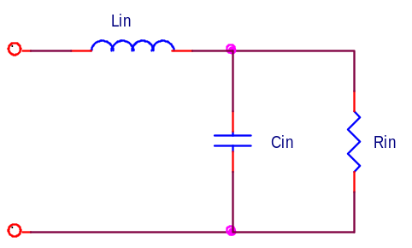

Figure 1: Replacement diagram at ballast’s control terminals
The robustness can be increased with the optional implementation of:
- Polarity insensitive interface input
- Over voltage protection for accidental mains voltage between the control wires

Transmission characteristics
- The transmission rate, expressed in bandwidth, is specified with 1,200 Hz for the forward channel and for the backward channel.
- All specified voltage and current levels refer to the terminals of the electronic ballast.
- A forward message frame consists of 19 bits (see Appendix: Pulse Diagram):
- 1 start bit
- 1 address Byte: 1 individual or group address bit, 6 address bits, 1 select bit
- 1 data byte: 8 data bits
- 2 stop bits
- A backward message frame consists of 11 bits (see Appendix: Pulse Diagram):
- 1 start bit
- 1 data byte: 8 data bits
- 2 stop bits

Test conditions
- The test conditions of the ballast are according to IEC1547 and for mains power interrupts (0.2 sec) IEC669-2-1.
- To assure interoperability of ballasts from different manufacturers test procedures are introduced testing the correct interpretation of parameters and commands specified in this standard. The following test procedures are defined (see Appendix) and described in form of flow charts:
- Physical and Operational Parameters
- Arc Power Commands
- Configuration Commands
- Random Address Allocation
- Physical Address Allocation

Terminals marking
- Both interface terminals shall be marked with "da" for data.
If the interface is polarity sensitive the terminals shall be marked with "+" and "-" respectively.

General Comment
- In this draft "lamp“ is used for applications where a ballast operates one or multiple lamps.
- If a ballast is "switched off“ it shall be assumed that the ballast is supplied by mains furthermore but is in the stand-by mode.

E3.1 electrical specification

E3.1.1. Voltage-rating

The signal levels specified in Figure 2 are considered to be reasonable for reliable operation of an electronic ballast over the specified operating temperature of the ballast.
In general the interface voltage is high if there is no communication (idle state).
The slopes of the received and transmitted data signal shall be 10µs ≤ t_{fall} ≤ 100µs and 10 µs ≤ t_{rise} ≤ 100µs at the ballast terminals of the digital interface.
The specified t_{fall} and t_{rise} are achievable under all configurations of types of wires and cable lengths.

10µs ≤ t_{fall} ≤ 100µs
10µs ≤ t_{rise} ≤ 100µs
V
416.67 µs ±10 %
High level: 9.5 to 22.5 V. Typical 16 V.

90%

10%

Low level : -6.5 to +6.5 V. Typical 0 V
t

833.33 µs ±10 % Bi-phase logical ”1”

Figure 2: Required timing at the ballast terminals of the digital interface

The voltage range shall be between 9.5 V and 22.5 V for ”high level" and between -6.5 V and +6.5 V for "low level" respectively. Between 6.5 V and 9.5 V the level is undefined.

E3.1.2 Current rating
In non-active state the ballast shall not exceed 2 mA @ ≤22.5 V because of the actual maximum number of ballasts per control unit. This shall be guaranteed by each ballast manufacturer.
The ballast shall be able to sink at least 250 mA @ ≤ 4.5 V at active state. The ballast shall keep the interface voltage lower than 4.5 V.
The interface power supply shall limit the supply current to max. 250 mA under all circumstances.
The interface specification at the ballast terminals shall be:
active state: low voltage level ≤ 4.5 V; high current level ≤ 250 mA (lim. by the power supply).
non-active state: high voltage level ≤ 22.5 V, low voltage level ≤ 6.5 V; high current ≤ 2 mA
See Figure 3 and Appendix: Voltage Ratings

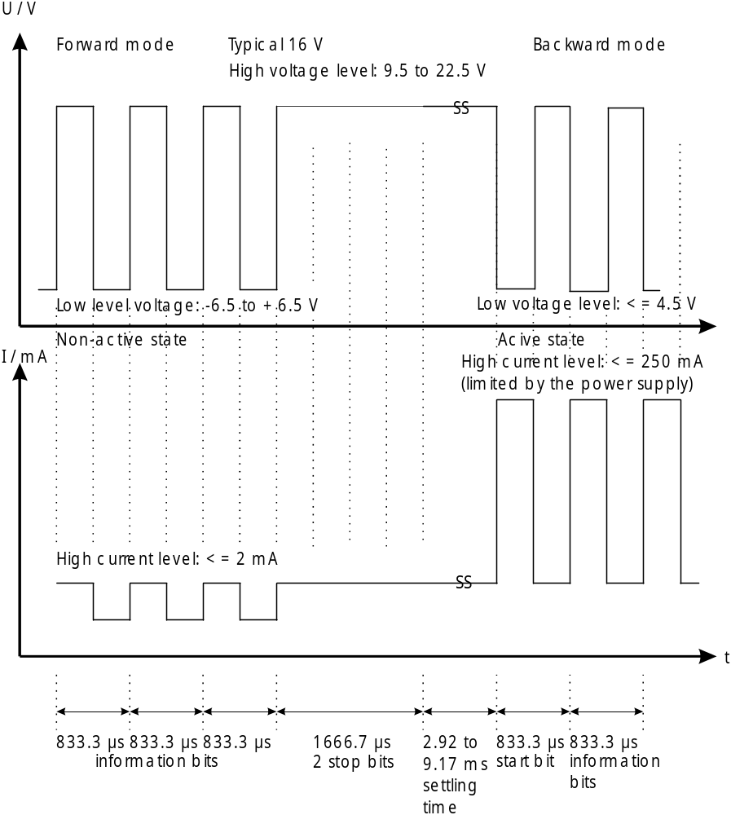

Figure 3 : Voltage and current levels for forward and backward channeling at the ballast's digital interface terminals
E3.2 OPERATIONal specification

E3.2.1. METHOD OF OPERATION
Way of Operation
The ballast operates in the master-slave mode where the ballast is the slave and any control unit is the master. In consequence the ballast transmits only information on request and the ballast offers no features supporting collision avoidance or collision handling methods in the backward mode.

Logarithmic dimming curve, arc power levels and accuracy
The lowest dimming level of the ballast is 0.1 % and shall be coupled to the digital value 1 in the range of 1 to 254 (absolute dimming). The highest arc power level of the ballast (100%) shall be coupled to the digital value 254. A logarithmic dimming curve from 0.1 % to 100 % is defined (see Appendix: Dimming curve). Because of the many different influences, dim levels can only have the meaning of arc power level of a lamp.
The relative accuracy of the dimming curve shall be ±½ step, monotonous. The absolute accuracy of the arc power level shall be specified by the ballast manufacturer.

Power-On
The interface signals shall be received properly 0.5 sec after ‘Power-On’.
Earliest after another 0.1 sec the ballast shall go to the ‘POWER-ON LEVEL’ via preheat- (if applicable) and ignition phase. The ballast shall not go in the reset status.
During the 0.1 sec interval the ballast shall react on a possible command if this ‘POWER-ON LEVEL’ is not desired.

Interface-failure
In case of the interface idle voltage is permanently below the specified receiver high level range (see Appendix: Voltage ratings) during more than 500 ms the ballast shall check the content of the ‘SYSTEM FAILURE LEVEL’.
If ‘MASK’ is stored the ballast shall stay in the state it is (no change of the arc power level, no switching on or off). In case of any other value stored, the ballast shall go to this arc power level immediately without fading. After the return of idle voltage the ballast shall not change its state.

Min and Max Level
Programming a MIN LEVEL above or a MAX LEVEL below the actual arc power level shall set the actual arc power level to the new MIN LEVEL or MAX LEVEL. Programming a MIN LEVEL below or a MAX LEVEL above the actual arc power level shall not affect the actual arc power level.
All arc power levels stored in the ballast shall not be restricted by the MIN and MAX LEVEL settings. Nevertheless those levels shall cause the ballast to operate at MIN LEVEL or MAX LEVEL if the stored value is below the MIN LEVEL or above the MAX LEVEL.
The arc power levels '0' (OFF) and '255' (MASK) shall not be affected by the MIN and
MAX LEVEL settings.

E3.2.2 TRANSMISSION PROTOCOL
Timing
The requirements for transmission are (see Figure 4):
- The settling time between two subsequent forward frames shall be 9.17 ms minimum. Then 4 forward frames with accompanying periods of 9.17 ms shall fit exactly in 100 ms.
- The settling time between forward and backward frames shall be 2.92 - 9.17 ms. The control unit shall wait up to 9.17 ms. If no backward frame has been started after 9.17 ms this shall be interpreted as no answer.
- The settling time between backward and forward frames shall be at least 9.17 ms.

In certain cases the command repetition time shall be 100 ms (1 forward frame in 100 ms). This is explicitly mentioned at the concerning commands.
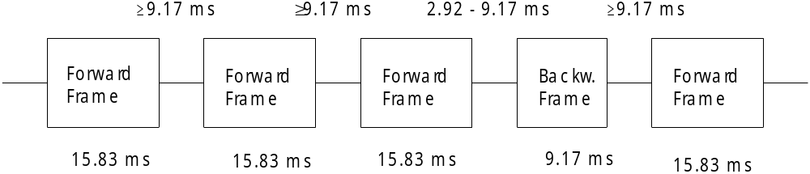

Figure 4 : Example of command repetition time

Frame structure
A forward frame shall consist of bi-phase coded bits: 1 start bit (logical ‘1’), 1 address byte and 1 data byte. The frame shall be terminated by 2 stop bits (idle). The stop bits shall not contain any change of phase (see Appendix: Pulse diagram).
A backward frame shall consist of bi-phase coded bits: 1 start bit (logical ‘1’) and 1 data byte. The frame shall be terminated by 2 stop bits (idle). The stop bits shall not contain any change of phase (see Appendix: Pulse diagram).
The frame structure shall be tested in the receiving unit. In case of code violation the frame shall be ignored. 1.7 ms after the occurrence of a code violation the ballast shall be ready again for data reception.
Query commands shall be of the kind that they can be answered with ‘Yes’, ‘No’ or 8-bit information. The answers shall be also bi-phase coded except for the answer ‘No’:
- 'Yes': 1111 1111
- 'No' : The ballast shall not react
- 8-bit information: XXXX XXXX
E3.3 specification of commands

E3.3.1 Structure of the digital commands
Every ballast shall be able to have 1 short address, 16 group addresses and shall react to broadcast commands.
Every ballast shall be able to store 16 scenes, a fade rate, a fade time, the MIN-, MAX-, POWER-ON and SYSTEM FAILURE levels.
Every ballast shall be able to send information back on request.
Declaration of variables
 | VARIABLE | DEFAULT VALUE  (ballast leaves the factory) | RESET VALUE | RANGE OF  VALIDITY | PERSISTENT MEMORY  (memory time: infinitely)
 | ‘Actual dim level’ | ???? ???? | 254 | 0,  min. – max, | ----  (1 byte RAM)
*) | ‘power on level’ | 254 | 254 | 1 – 254, | 1 byte
*) | ‘system failure level’ | 254 | 254 | 0 - 255 (‘MASK’) | 1 byte
 | ‘min level’ | ‘physical min level’ | ‘physical min level’ | PHYS. MIN – MAX LEVEL | 1 byte
 | ‘max level’ | 254 | 254 | MIN LEVEL - 254 | 1 byte
 | ‘fade rate’ | 7  (45 steps/sec) | 7  (45 steps/sec) | 1 - 15 | 1 byte
 | ‘fade time’ | 0 (no fade) | 0 (no fade) | 0 - 15 | 1 byte
 | ‘short address’ | 255 (‘mask’)  no address | no change | 0 - 63, 255 (‘MASK’), | 1 byte
 | ‘SEARCH address’ | FF FF FF | FF FF FF | 00 00 00 -  FF FF FF | ----  (3 bytes RAM)
 | ‘RANDOM ADDRESS’ | FF FF FF | FF FF FF | 00 00 00 -  FF FF FF | 3 bytes
 | ‘group 0-7’ | 0000 0000  (no group) | 0000 0000  (no group) | 0 – 255 | 1 byte
 | ‘group 8-15’ | 0000 0000  (no group) | 0000 0000  (no group) | 0 – 255 | 1 byte
*) | ‘scene 0-15’ | 255 (‘mask’) | 255 (‘mask’) | 0 - 255 (‘MASK’) | 16 bytes
 | ‘status information’ | ???? ???? | 0?100??? | 0 -- 255 | ----  (1 byte RAM)
 | ‘version number’  (See top of this document) | factory burn-in | factory burn-in | 0 - 255 | ----  (1 byte ROM)
 | 'PHYSICAL MIN. LEVEL' | factory burn-in | factory burn-in | 1 - 254 | ----  (1 byte ROM)

? = undefined

*) The actual arc power shall be restricted by the min / max level range (see chapter E3.2.1.)

E3.3.2. Addresses
Every standard ballast shall be able to react to a short address, 16 group addresses and broadcast. The following addressing scheme shall be used.

Type of addresses: address byte:
Short or group address YAAAAAAS
64 Short addresses 0 - 63 0AAAAAAS
16 group addresses 0 - 15 100AAAAS
broadcast 1111111S

special command: address byte:
part of address commands 101CCCC1
and 110CCCC1 (see E3.3.3.4)

A: significant address bit
S: selector bit: S = ‘0’ direct arc power level following S = ‘1’ command following
C: significant "ADDR. COMMAND" bit
Y: short- or group address/broadcast: Y = ‘0’ short address Y = ‘1’: group address or broadcast

The eighth bit of the first byte shall be used as a selector bit. It describes whether a direct arc power level control or command is following in the second byte.
Future extension of address space shall avoid the first three most significant bits 101 and 110. These combinations are used for special commands (see E3.3.3.4).
When the ballast is attached to a system it already has a short address or it reacts only to broadcast commands. The short address is given either by hardware means or by using the defined commands. The group addresses shall be programmed using the defined commands.

E3.3.3. Command set
In the following command bytes ‘X’ stands for ‘0’ or ‘1’. Comments are written in italics.
Every new command shall be processed immediately after reception except otherwise stated.

E3.3.3.1 Arc power control Commands

E3.3.3.1.1 Direct arc power control Command: YAAA AAA0 XXXX XXXX
Setting the arc power level directly with the actual fade time according to the formula
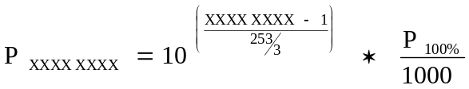
Direct control commands outside the 'MAX LEVEL' and 'MIN LEVEL' shall result in setting the arc power level to the respective MAX and MIN LEVEL. If the lamp is off it shall be ignited with this command.
There are two direct control commands having a special meaning:
- 0000 0000 the ballast dims down to the ‘MIN LEVEL’ with the actual fade time and switches off
- 1111 1111 means ‘MASK’ or ‘DON’T CHANGE’; this value shall be further ignored and therefore not stored in a memory.

E3.3.3.1.2 Indirect arc power control Commands:
Command 0: YAAA AAA1 0000 0000 ‘OFF’
Extinguish the lamp immediately without fading

Command 1: YAAA AAA1 0000 0001 ‘UP’
Dim up 200 ms using the selected FADE RATE.
No change if the arc power output is already at the ‘MAX LEVEL’
If this command is received again while it is been executed, the command shall be re-triggered.
This command shall only affect ballasts with burning lamps. No lamp shall be ignited with this command.

Command 2: YAAA AAA1 0000 0010 ‘DOWN’
Dim down 200 ms using the selected FADE RATE.
No change if the arc power output is already at the ‘MIN LEVEL’
If this command is received again while it is been executed, the command shall be re-triggered.
Lamp shall not be switched off via this command.

Command 3: YAAA AAA1 0000 0011 ‘STEP UP’
Set the actual arc power level one step higher immediately without fading.
No change if the arc power output is already at the ‘MAX LEVEL’.
This command shall only affect ballasts with burning lamps. No lamp shall be ignited with this command.

Command 4: YAAA AAA1 0000 0100 ‘STEP DOWN’
Set the actual arc power level one step lower immediately without fading.
Lamps shall not be switched off via this command.
No change if the arc power output is already at the ‘MIN LEVEL’.
Command 5: YAAA AAA1 0000 0101 ‘RECALL MAX LEVEL’
Set the actual arc power level to the ‘MAX LEVEL’ without fading. If the lamp is off it shall be ignited with this command.

Command 6: YAAA AAA1 0000 0110 ‘RECALL MIN LEVEL’
Set the actual arc power level to the ‘MIN LEVEL’ without fading. If the lamp is off it shall be ignited with this command.

Command 7: YAAA AAA1 0000 0111 ‘STEP DOWN AND OFF’
Set the actual arc power level one step lower immediately without fading.
If the actual arc power level is already at the ‘MIN LEVEL’ the lamp shall be switched off by this command.

Command 8: YAAA AAA1 0000 1000 ‘ON AND STEP UP’
Set the actual arc power level one step higher immediately without fading.
If the lamp is switched off the lamp shall be ignited with this command and shall be set to the ‘MIN LEVEL’.

Command 9 - 15: YAAA AAA1 0000 1XXX
Reserved for future needs.

Command 16 - 31: YAAA AAA1 0001 XXXX ‘GO TO SCENE’
Set the actual arc power level to the value stored for scene XXXX using the actual fade time.
If the ballast does not belong to scene XXXX, the arc power level remain unchanged.
If the lamp is off it shall be ignited with this command.

E3.3.3.2. Configuration Commands:
Every configuration command (32 - 128) shall be received a second time in the next 100 ms before it shall be executed in order to increase the probability for a proper reception. No other commands addressing the same ballast shall be sent between these two commands, otherwise these commands shall be ignored and the respective configuration sequence shall be aborted.
All values of DTR shall be checked against the values mentioned in E3.3.1, RANGE OF VALIDITY. I.e. the value shall be set to the upper / lower limit if it is above / below the valid range defined in E3.3.1.
E3.3.3.2.1. General configuration commands:
Command 32: YAAA AAA1 0010 0000 ‘RESET’
After the second reception of the command the variables in the persistent memory (see table E3.3.1) shall be changed to their reset values. It is not guarantied that commands are received properly within the next 300 ms.

Command 33: YAAA AAA1 0010 0001 ‘STORE ACTUAL LEVEL IN THE DTR’
Store actual arc power level in the DTR without changing the current light intensity.

Command 34 - 41: YAAA AAA1 0010 XXXX
Reserved for future needs.

E3.3.3.2.2. Arc power parameters settings:
Command 42: YAAA AAA1 0010 1010 ‘STORE THE DTR AS MAX LEVEL’
Save the value in ‘Data Transfer Register’ as new ‘MAX LEVEL'.

Command 43: YAAA AAA1 0010 1011 ‘STORE THE DTR AS MIN LEVEL’
Save the value in ‘Data Transfer Register’ as new ‘MIN LEVEL' . If this value is lower as the 'physical min. level' of the ballast, then store the 'physical min. level' as new ‘min LEVEL'.

Command 44: YAAA AAA1 0010 1100 ‘STORE THE DTR AS SYSTEM FAILURE level’
Save the value in ‘Data Transfer Register’ as new ‘system failure level’.

Command 45: YAAA AAA1 0010 1101 ‘STORE THE DTR AS POWER ON LEVEL’
Save the value in ‘Data Transfer Register’ as new ‘POWER ON LEVEL'.

Command 46: YAAA AAA1 0010 1110 ‘STORE THE DTR AS FADE TIME’
Set the ‘fade time’ to a value according to the following formula
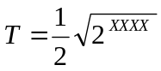 sec with XXXX = 1 - 15, the four least significant bits of the DTR register: 0000 XXXX
(tolerance: ± ½ step; monotonous). See Appendix: Fade time and fade rate.
XXXX = 0 means no fade (<0.7 sec).
The fade time specifies the time for changing the arc power level from the actual level to the requested level. In case of lamp off the preheat and ignition time is not included in the fade time.
The new fade time shall be valid after the reception of the next arc power command. If a new fade time is downloaded during a running fade process this process shall be finished first before the new value shall be used.
Command 47 YAAA AAA1 0010 1111 ‘STORE THE DTR AS FADE RATE’
Set the ‘fade rate’ to the value according to the formula
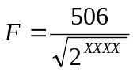 steps / sec
with XXXX = 1 - 15, the four least significant bits of the DTR register: 0000 XXXX
(tolerance: ± ½ step; monotonous). See appendix: fade time and fade rate.
The fade rate specifies the rate in steps / sec for changing the arc power level.
The new fade rate shall be valid after the reception of the next arc power command. If a new fade rate is downloaded during a running fade process this process shall be finished first before the new value shall be used.

Command 48 - 63: YAAA AAA1 0011 XXXX
Reserved for future needs.

Command 64-79: YAAA AAA1 0100 XXXX ‘STORE THE DTR AS SCENE’
Save the value in Data Transfer Register as a new level of the scene XXXX.

E3.3.3.2.3 System parameters settings
Command 80- 95: YAAA AAA1 0101 XXXX ‘REMOVE FROM SCENE’
Remove the ballast from scene XXXX.
Removing the ballast from scene XXXX means storing 1111 1111 ('MASK' or 'DON’T CHANGE') in scene register XXXX.

Command 96 - 111: YAAA AAA1 0110 XXXX ‘ADD TO GROUP’
Add the ballast to group XXXX.

Command 112 - 127: YAAA AAA1 0111 XXXX ‘REMOVE FROM GROUP’
Remove the ballast from group XXXX.
Removing the ballast from group XXXX means storing ‘0’ in the group register

Command 128: YAAA AAA1 1000 0000 ‘STORE DTR AS SHORT ADDRESS’
Save the value in the DTR as new short address.
The structure of the DTR shall be: XXXX XXXX = 0AAA AAA1 or 1111 1111 (‘MASK’). MASK shall remove the short address.

Command 129 - 143: YAAA AAA1 1000 XXXX
Reserved for future needs.
E3.3.3.3. Query Commands
Query commands shall be addressed to individual ballasts preferably. If addressed to groups or broadcast the answers might be overlapped as all ballasts addressed will answer.
Query commands shall be of the kind that they can be answered with ‘Yes’, ‘No’ or 8-bit information. The answers shall be also bi-phase coded except for the answer ‘No’:
- 'Yes': 1111 1111
- 'No' : The ballast shall not react
- 8-bit information: XXXX XXXX

E3.3.3.3.1 Queries related to status information
If the parameters listed in E3.3.1 have their reset values the ballast shall be in the ‘RESET state’:

Command 144: YAAA AAA1 1001 0000 ‘QUERY status'
Answer is the following ‘status information’ byte:
bit 0 Status of ballast; ‘0’ = OK
bit 1 Lamp failure; ‘0’ = OK
bit 2 Lamp arc power on; ‘0’ = OFF
bit 3 Query: Limit Error; ‘0’ = Last requested arc power level is between MIN..MAX LEVEL or OFF
bit 4 Fade ready; ‘0’ = fade is ready; ‘1’ = fade is running
bit 5 Query: ‘reset state’? ‘0’ = ‘No’
bit 6 Query: Missing short address? ‘0’ = ‘No’
bit 7 Query: ‘Power failure’? ‘0’ = ‘No’; ‘RESET’ or an arc power control command has been received after last power-on.

The ‘status information’ shall be available in the RAM memory of the ballast and shall be updated regularly by the ballast according to the actual situation.

Command 145: YAAA AAA1 1001 0001 ‘QUERY BALLAST’
Ask if there is a ballast with the given address that is able to communicate. Answer shall be ‘Yes’ or ‘No’.

Command 146: YAAA AAA1 1001 0010 ‘QUERY LAMP FAILURE’
Ask if there is a lamp problem at the given address. Answer shall be ‘Yes’ or ‘No’.

Command 147: YAAA AAA1 1001 0011 ‘QUERY LAMP POWER ON’
Ask if there is a lamp operating at the given address. Answer shall be ‘Yes’ or ‘No’.

Command 148: YAAA AAA1 1001 0100 ‘QUERY LIMIT ERROR'
Ask if the last requested arc power level at the given address could not be met, because it is above the MAX LEVEL or below the MIN LEVEL. Answer shall be ‘Yes’ or ‘No’.

Command 149: YAAA AAA1 1001 0101 ‘QUERY RESET STATE’
Ask if the ballast is in ‘RESET STATE’. Answer shall be ‘Yes’ or ‘No’.

Command 150: YAAA AAA1 1001 0110 ‘QUERY MISSING SHORT ADDRESS’
Ask if the ballast has no short address. Answer shall be ‘Yes’ or ‘No’.
The answer shall be ‘Yes’ if the ballast has no short address.

Command 151: YAAA AAA1 1001 0111 ‘QUERY VERSION NUMBER’
Ask for the version number of the IEC standard document met by the software and the hardware of the present ballast. The 'VERSION NUMBER' shall be stored in a ROM. Answer shall be the 'VERSION NUMBER' as an 8 bit number. The first 4 bits represent the major version; the second 4 bits represent the lower version. As e.g. version 3.5.
The actual 'VERSION NUMBER' is 0000 0000.

Command 152: YAAA AAA1 1001 1000 ‘QUERY CONTENT DTR ‘
Answer shall be the content of the DTR as an 8 bit number.

Command 153: YAAA AAA1 1001 1001 ‘QUERY DEVICE TYPE’
Answer shall be an 8 bit number (x = 0 to 255). The standard device type shall return the answer 0 (this device type shall not react on the application extended commands 224 to 255).
For the list of device types see command 272.

Command 154: YAAA AAA1 1001 1010 ‘QUERY physical minimum level‘
Answer shall be the 'physical min. level' as an 8 bit number. The 'physical min. level' shall be stored in a ROM.

Command 155: YAAA AAA1 1001 1011 ‘QUERY Power failure‘
Answer shall be ‘YES’ if the ballast has not received a ‘RESET’ or one of the following arc power control commands since the last power-on: ‘DIRECT ARC POWER CONTROL’, ‘OFF’, ‘RECALL MAX LEVEL’, ‘RECALL MIN LEVEL’, ‘STEP DOWN AND OFF’, ‘ON AND STEP UP’, ‘GO TO SCENE’

Command 156 – 159: YAAA AAAA 1001 11XX
Reserved for future needs.

E3.3.3.3.2 Queries related to arc power parameter settings
Command 160: YAAA AAA1 1010 0000 ‘QUERY ACTUAL LEVEL’
Answer shall be this level as an 8 bit number.

Command 161: YAAA AAA1 1010 0001 ‘QUERY MAX LEVEL’
Answer shall be this level as an 8 bit number.

Command 162: YAAA AAA1 1010 0010 ‘QUERY MIN LEVEL’
Answer shall be this level as an 8 bit number.

Command 163: YAAA AAA1 1010 0011 ‘QUERY POWER ON LEVEL’
Answer shall be this level as an 8 bit number.
Command 164: YAAA AAA1 1010 0100 ‘QUERY SYSTEM FAILURE LEVEL’
Answer shall be this level as an 8 bit number.

Command 165: YAAA AAA1 1010 0101 ‘QUERY FADE TIME / fade rate’
Answer shall be XXXX YYYY where XXXX corresponds with the number of command 46 and where YYYY corresponds with the number of command 47.

Commands 166-175: YAAA AAA1 1010 XXXX
Reserved for future needs.

E3.3.3.3.3 Queries related to system parameter settings
Command 176-191: YAAA AAA1 1011 XXXX ‘QUERY SCENE LEVEL (SCENES 0-15)’
Answer shall be the arc power level of scene XXXX as an 8 bit number.

Command 192: YAAA AAA1 1100 0000 ‘QUERY GROUPS 0-7’
One bit for each group in back channel data byte. Lsb = group 0.
‘0’ = not belonging to group. ‘1’ = belonging to group.

Command 193: YAAA AAA1 1100 0001 ‘QUERY GROUPS 8-15’
One bit for each group in back channel data byte. Lsb = group 8.
‘0’ = not belonging to group. ‘1’ = belonging to group.

Command 194: YAAA AAA1 1100 0010 ‘QUERY RANDOM ADDRESS (H)’
The 8 high bits of the random address.

Command 195: YAAA AAA1 1100 0011 ‘QUERY RANDOM ADDRESS (M)’
The 8 mid bits of the random address.

Command 196 YAAA AAA1 1100 0100 ‘QUERY RANDOM ADDRESS (L)’
The 8 low bits of the random address.

Commands 197-223: YAAA AAA1 110X XXXX
Reserved for future needs.

E3.3.3.3.4 Application extended commands
Commands 224-255: YAAA AAA1 11XX XXXX ‘QUERY APPLICATION EXTENDED
COMMANDS’
These commands shall be defined in the annexes of the concerning special device types. Further comments see command 272.
For the standard device type 0 these commands are not used.
E3.3.3.4. Special Commands
Special Commands shall be broadcasted to and received by all ballasts. This means that the main address shall be 101C CCC1.or 110C CCC1. C is the significant ‘SPECIAL COMMAND’ bit.

E3.3.3.4.1 Terminate special processes
Command 256: 1010 0001 0000 0000 ‘TERMINATE’
All special mode processes shall be terminated.

E3.3.3.4.2. Download information to the DTR
Command 257: 1010 0011 XXXX XXXX ‘DATA TRANSFER REGISTER (DTR)’
Store 8 bit value XXXX XXXX to DTR.

E3.3.3.4.3. Addressing Commands
The address range shall be set to a maximum of 24-bits (3 bytes) which leads to 16.777.216 different addresses.
There are Addressing Commands where the ballast shall respond as it was a Query Command.

Command 258: 1010 0101 XXXX XXXX ‘INITIALISE’
This command shall be sent a second time in the next 100 ms. No other commands shall be sent between these two commands, otherwise the other command and Command 258 shall be ignored.
The command shall start or re-trigger a timer for 15 minutes; the addressing commands 259 to 270 can only be processed within this period. The other commands can still be processed during this period.
This time period shall be aborted with the 'terminate' command.
The reaction of ballasts receiving this command depends on the content of the 2nd byte:
XXXX XXXX = 0000 0000 All ballasts shall react
XXXX XXXX = 0AAA AAA1 Ballasts with the address AAA AAA shall react
XXXX XXXX = 1111 1111 Ballasts without short address shall react

Command 259: 1010 0111 0000 0000 ‘RANDOMISE’
This command shall be sent a second time in the next 100 ms. No other commands shall be sent between these two commands, otherwise these shall be ignored.
The ballast shall generate a new random address on the request of this command.
The new random address shall be available within a time period of 100 ms.

Command 260: 1010 1001 0000 0000 ‘COMPARE ’
The ballast shall compare it’s random address with the combined search address stored in SEARCHADDRH, SEARCHADDRM and SEARCHADDRL. If it’s random address is smaller or equal to the combined search address stored in SEARCHADDRH, SEARCHADDRM and SEARCHADDRL then the ballast shall generate a query ”YES”.

Command 261: 1010 1011 0000 0000 ‘WITHDRAW’
The ballast with it’s random address that is equal to the combined search address stored in SEARCHADDRH, SEARCHADDRM and SEARCHADDRL shall be excluded from the compare process. This ballast shall not be separated from the initialization process.

Command 262: 1010 1101 0000 0000 Reserved for future needs

Command 263: 1010 1111 0000 0000 Reserved for future needs

Command 264 1011 0001 HHHH HHHH ‘SEARCHADDRH’
The 8 high bits of the search address.

Command 265 1011 0011 MMMM MMMM ‘SEARCHADDRM’
The 8 mid bits of the search address.

Command 266 1011 0101 LLLL LLLL ‘SEARCHADDRL’
The 8 low bits of the search address.

The combination of the three addresses from command 264 to 266 shall represent the 24 bits search address HHHHHHHHMMMMMMMMLLLLLLLL.

Command 267: 1011 0111 0AAA AAA1 ‘PROGRAM SHORT ADDRESS’
The ballast shall store the received 6 bits address as it’s short address if it is selected.
‘Selected’ means:
- The ballast’s random address shall be equal to the combined search address stored in SEARCHADDRH, SEARCHADDRM and SEARCHADDRL.
- Physical selection for individual addressing of the ballast. Physical selection shall be detected by the ballast if a lamp is electrically disconnected from the ballast after reception of Command 270.
The short address shall be deleted by the following completion of
command 267: 1011 0111 1111 1111 ‘delete the short address’

Command 268: 1011 1001 0AAA AAA1 ‘VERIFY SHORT ADDRESS’
The ballast shall give a Query ”YES” if the received short address is equal to it’s own short address.

Command 269: 1011 1011 0000 0000 ‘QUERY SHORT ADDRESS’
The ballast shall send the short address if the random address is the same as the search address or the ballast is physical selected.

Command 270: 1011 1101 0000 0000 ‘PHYSICAL SELECTION’
If a ballast receives this command it shall cancel its physical selection and shall set the ballast to "Physical Selection Mode". In this mode the compare of SEARCH and RANDOM ADDRESS shall be disabled.

Command 271: 1011 1111 XXXX XXXX Reserved for future needs

Command 272: 1100 0001 XXXX XXXX ‘ENABLE DEVICE TYPE X’
X = 0 to 255. This command shall be sent before a broadcast or group command, if that command is an application extended command (224 – 255) and there is more then one device type on the interface. If a short address is used this command shall not be necessary to access one of the application extended commands.
This command can be processed without the use of the INITIALISE command.
This command shall not be used for device type 0, because the application extended commands 224-255 are not used for this device type.
List of device types x:
x = 0 standard device
x = 1 device for emergency lighting
x = 2 device for HID lamps
x = 3 device for low voltage halogen lamps
x = 4 device for dimming of incandescent lamps
x = 5....255 reserved for future device types
Restrictions:
- A device may not react on commands which belongs to the application extended commands of other devices.
- All devices shall be able to respond in an appropriate way on the standard range of commands
- Control units shall be able to identify individual devices and store the relationship between device's individual address and the device type in a persistent memory.

Commands 273-287 110x xxx1 xxxx xxxx
Reserved for future special commands.

E3.3.4. EXAMPLEs OF algorithms FOR THE ADDRESSING COMMANDS
Ballasts in a lighting control system with random addressing:
- After 'POWER ON' all ballasts shall have 100 % arc power level (Default value after ‘RESET’).
- Start the algorithm with command 258 'INITIALISE' which enables the next addressing commands for 15 minutes.
- Send command: 259 'RANDOMISE':
All ballasts choose a binary random number (BRN) so that 0 ≤ BRN ≤ +2²⁴-1.
- The control unit searches the ballast with the lowest BRN by means of an algorithm which uses
command 264 to 266 and command 260 'COMPARE'. The ballast with the lowest BRN is found.
- The found ballast becomes an unique 6 bits short address with aid of
command 267 'PROGRAM SHORT ADDRESS'.
- Verify the programmed SHORT ADDRESS with command 268 'VERIFY SHORT ADDRESS'.
- The found ballast shall be retracted from the search process by means of command 261 'WITHDRAW.
- If not all ballasts are found, repeat from step 4) on until no further ballast can be found.
- Stop the process with the command 256 'TERMINATE'.
- Recall e.g. min and max level with the short addresses used and record the local position of the respective ballast.
- In case of two or more ballasts having the same short address, restart the addressing procedure only for these ballasts with the ‘INITIALISE‘ command (using the short address in the second byte) followed by step 3) to 9) and finalize step 10).

Only one ballast connected separately to the control unit for a simplified addressing method:
Send first the new short address (0AAA AAA1) by command 257 'DATA TRANSFER REGISTER (DTR)', verify the content of the DTR and send command 128 'STORE DTR AS SHORT ADDRESS' two times.

Ballasts in a lighting control system with addressing by means of physical selection:
- The control unit shall send command 258 INITIALISE
- The control unit shall send command 270 PHYSICAL SELECTION
- The control unit shall repeat command 269 QUERY SHORT ADDRESS periodically until a ballast replies (this ballast is physical selected).
- The control unit shall send command 267 PROGRAM SHORT ADDRESS containing the ballast's address.
- The control unit shall send RECALL MIN LEVEL and RECALL MAX LEVEL using the short address for optical feedback for some seconds.
- Steps 2 to 5 shall be repeated for all ballasts.
- The control unit shall send command 256 TERMINATE. By this the ballasts shall leave the Physical Selection Mode and shall return to normal operation.

Application of the special device type commands
- Initialization process (start addressing)
- Allocation individual addresses
- Do a query for special and standard devices
- Transmit " enable device type " in case of using broadcast or group commands in only one specific application (and more then one application is on the bus),
- After this command, a command out of the application extended command block shall follow.
E3.3.5. SUMMARY OF THE COMMAND SET
Command Number | Command Code | Command Name
- | YAAA AAA0 XXXX XXXX | DIRECT ARC POWER CONTROL
0 | YAAA AAA1 0000 0000 | OFF
1 | YAAA AAA1 0000 0001 | UP
2 | YAAA AAA1 0000 0010 | DOWN
3 | YAAA AAA1 0000 0011 | STEP UP
4 | YAAA AAA1 0000 0100 | STEP DOWN
5 | YAAA AAA1 0000 0101 | RECALL MAX LEVEL
6 | YAAA AAA1 0000 0110 | RECALL MIN LEVEL
7 | YAAA AAA1 0000 0111 | STEP DOWN AND OFF
8 | YAAA AAA1 0000 1000 | ON AND STEP UP
9-15 | YAAA AAA1 0000 1XXX | RESERVED
16 - 31 | YAAA AAA1 0001 XXXX | GO TO SCENE
32 | YAAA AAA1 0010 0000 | RESET
33 | YAAA AAA1 0010 0001 | STORE ACTUAL LEVEL IN THE DTR
34 - 41 | YAAA AAA1 0010 XXXX | RESERVED
42 | YAAA AAA1 0010 1010 | STORE THE DTR AS MAX LEVEL
43 | YAAA AAA1 0010 1011 | STORE THE DTR AS MIN LEVEL
44 | YAAA AAA1 0010 1100 | STORE THE DTR AS SYSTEM FAILURE LEVEL
45 | YAAA AAA1 0010 1101 | STORE THE DTR AS POWER ON LEVEL
46 | YAAA AAA1 0010 1110 | STORE THE DTR AS FADE TIME
47 | YAAA AAA1 0010 1111 | STORE THE DTR AS FADE RATE
48 - 63 | YAAA AAA1 0011 XXXX | RESERVED
64 - 79 | YAAA AAA1 0100 XXXX | STORE THE DTR AS SCENE
80 - 95 | YAAA AAA1 0101 XXXX | REMOVE FROM SCENE
96 - 111 | YAAA AAA1 0110 XXXX | ADD TO GROUP
112 -127 | YAAA AAA1 0111 XXXX | REMOVE FROM GROUP
128 | YAAA AAA1 1000 0000 | STORE DTR AS SHORT ADDRESS
129 -143 | YAAA AAA1 1000 XXXX | RESERVED
144 | YAAA AAA1 1001 0000 | QUERY STATUS
145 | YAAA AAA1 1001 0001 | QUERY BALLAST
146 | YAAA AAA1 1001 0010 | QUERY LAMP FAILURE
147 | YAAA AAA1 1001 0011 | QUERY LAMP POWER ON
148 | YAAA AAA1 1001 0100 | QUERY LIMIT ERROR
149 | YAAA AAA1 1001 0101 | QUERY RESET state
150 | YAAA AAA1 1001 0110 | QUERY MISSING SHORT ADDRESS
151 | YAAA AAA1 1001 0111 | QUERY VERSION NUMBER
152 | YAAA AAA1 1001 1000 | QUERY CONTENT DTR
153 | YAAA AAA1 1001 1001 | Query device type
154 | YAAA AAA1 1001 1010 | Query physical minimum level
155 | YAAA AAA1 1001 1011 | QUERY Power failure
156 - 159 | YAAA AAA1 1001 11XX | RESERVED

Command Number | Command Code | Command Name
160 | YAAA AAA1 1010 0000 | QUERY ACTUAL LEVEL
161 | YAAA AAA1 1010 0001 | QUERY MAX LEVEL
162 | YAAA AAA1 1010 0010 | QUERY MIN LEVEL
163 | YAAA AAA1 1010 0011 | QUERY POWER ON LEVEL
164 | YAAA AAA1 1010 0100 | QUERY SYSTEM FAILURE LEVEL
165 | YAAA AAA1 1010 0101 | QUERY FADE TIME / FADE RATE
166 - 175 | YAAA AAA1 1010 XXXX | RESERVED
176 - 191 | YAAA AAA1 1011 XXXX | QUERY SCENE LEVEL (SCENES 0-15)
192 | YAAA AAA1 1100 0000 | QUERY GROUPS 0-7
193 | YAAA AAA1 1100 0001 | QUERY GROUPS 8-15
194 | YAAA AAA1 1100 0010 | QUERY RANDOM ADDRESS (H)
195 | YAAA AAA1 1100 0011 | QUERY RANDOM ADDRESS (M)
196 | YAAA AAA1 1100 0100 | QUERY RANDOM ADDRESS (L)
197 - 223 | YAAA AAA1 110X XXXX | RESERVED
224 - 255 | YAAA AAA1 11XX XXXX | QUERY APPLICATION EXTEND. COMMANDS
256 | 1010 0001 0000 0000 | TERMINATE
257 | 1010 0011 XXXX XXXX | DATA TRANSFER REGISTER (DTR)
258 | 1010 0101 XXXX XXXX | INITIALISE
259 | 1010 0111 0000 0000 | RANDOMISE
260 | 1010 1001 0000 0000 | COMPARE
261 | 1010 1011 0000 0000 | WITHDRAW
262 | 1010 1101 0000 0000 | RESERVED
263 | 1010 1111 0000 0000 | RESERVED
264 | 1011 0001 HHHH HHHH | SEARCHADDRH
265 | 1011 0011 MMMM MMMM | SEARCHADDRM
266 | 1011 0101 LLLL LLLL | SEARCHADDRL
267 | 1011 0111 0AAA AAA1 | PROGRAM SHORT ADDRESS
268 | 1011 1001 0AAA AAA1 | VERIFY SHORT ADDRESS
269 | 1011 1011 0000 0000 | QUERY SHORT ADDRESS
270 | 1011 1101 0000 0000 | PHYSICAL SELECTION
271 | 1011 1111 XXXX XXXX | RESERVED
272 | 1100 0001 XXXX XXXX | ENABLE DEVICE TYPE X
273 - 287 | 110X xxx1 xxxx xxxx | RESERVED

E3.3.6 LIST OF APPENDICES
- Pulse diagram
- The logarithmic dimming curve with a minimum arc power level of 0.1% --- table
- The logarithmic dimming curve with a minimum arc power level of 0.1% --- diagram
- Voltage ratings
- Fade time and fade rate
- Test procedure physical and operational parameters
- Test procedure arc power control commands
- Test procedure configuration commands
- Test procedure random address allocation
- Test procedure physical address allocation

Appendix: Pulse diagram

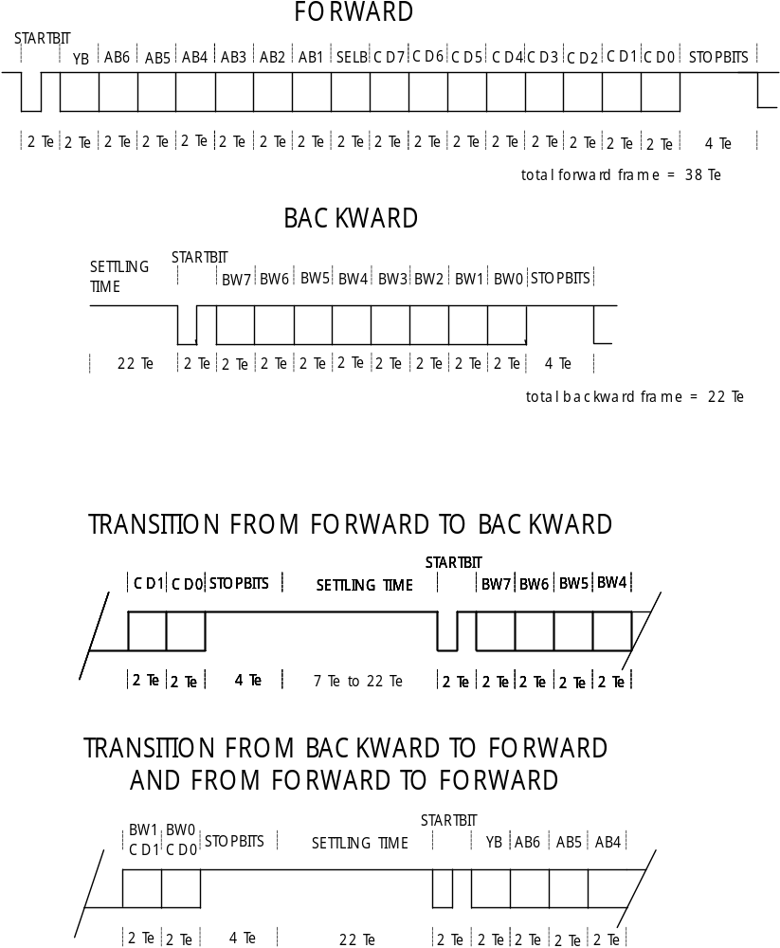

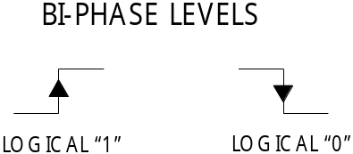

Appendix: The logarithmic dimming curve with a minimum arc power level of 0.1%

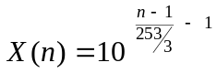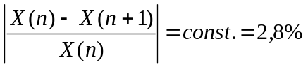

n | X | n | X | n | X | n | X | n | X
1 | 0.100 | 52 | 0.402 | 103 | 1.620 | 154 | 6.520 | 205 | 26.241
2 | 0.103 | 53 | 0.414 | 104 | 1.665 | 155 | 6.700 | 206 | 26.967
3 | 0.106 | 54 | 0.425 | 105 | 1.711 | 156 | 6.886 | 207 | 27.713
4 | 0.109 | 55 | 0.437 | 106 | 1.758 | 157 | 7.076 | 208 | 28.480
5 | 0.112 | 56 | 0.449 | 107 | 1.807 | 158 | 7.272 | 209 | 29.269
6 | 0.115 | 57 | 0.461 | 108 | 1.857 | 159 | 7.473 | 210 | 30.079
7 | 0.118 | 58 | 0.474 | 109 | 1.908 | 160 | 7.680 | 211 | 30.911
8 | 0.121 | 59 | 0.487 | 110 | 1.961 | 161 | 7.893 | 212 | 31.767
9 | 0.124 | 60 | 0.501 | 111 | 2.015 | 162 | 8.111 | 213 | 32.646
10 | 0.128 | 61 | 0.515 | 112 | 2.071 | 163 | 8.336 | 214 | 33.550
11 | 0.131 | 62 | 0.529 | 113 | 2.128 | 164 | 8.567 | 215 | 34.479
12 | 0.135 | 63 | 0.543 | 114 | 2.187 | 165 | 8.804 | 216 | 35.433
13 | 0.139 | 64 | 0.559 | 115 | 2.248 | 166 | 9.047 | 217 | 36.414
14 | 0.143 | 65 | 0.574 | 116 | 2.310 | 167 | 9.298 | 218 | 37.422
15 | 0.147 | 66 | 0.590 | 117 | 2.374 | 168 | 9.555 | 219 | 38.457
16 | 0.151 | 67 | 0.606 | 118 | 2.440 | 169 | 9.820 | 220 | 39.522
17 | 0.155 | 68 | 0.623 | 119 | 2.507 | 170 | 10.091 | 221 | 40.616
18 | 0.159 | 69 | 0.640 | 120 | 2.577 | 171 | 10.371 | 222 | 41.740
19 | 0.163 | 70 | 0.658 | 121 | 2.648 | 172 | 10.658 | 223 | 42.895
20 | 0.168 | 71 | 0.676 | 122 | 2.721 | 173 | 10.953 | 224 | 44.083
21 | 0.173 | 72 | 0.695 | 123 | 2.797 | 174 | 11.256 | 225 | 45.303
22 | 0.177 | 73 | 0.714 | 124 | 2.874 | 175 | 11.568 | 226 | 46.557
23 | 0.182 | 74 | 0.734 | 125 | 2.954 | 176 | 11.888 | 227 | 47.846
24 | 0.187 | 75 | 0.754 | 126 | 3.035 | 177 | 12.217 | 228 | 49.170
25 | 0.193 | 76 | 0.775 | 127 | 3.119 | 178 | 12.555 | 229 | 50.531
26 | 0.198 | 77 | 0.796 | 128 | 3.206 | 179 | 12.902 | 230 | 51.930
27 | 0.203 | 78 | 0.819 | 129 | 3.294 | 180 | 13.260 | 231 | 53.367
28 | 0.209 | 79 | 0.841 | 130 | 3.386 | 181 | 13.627 | 232 | 54.844
29 | 0.215 | 80 | 0.864 | 131 | 3.479 | 182 | 14.004 | 233 | 56.362
30 | 0.221 | 81 | 0.888 | 132 | 3.576 | 183 | 14.391 | 234 | 57.922
31 | 0.227 | 82 | 0.913 | 133 | 3.675 | 184 | 14.790 | 235 | 59.526
32 | 0.233 | 83 | 0.938 | 134 | 3.776 | 185 | 15.199 | 236 | 61.173
33 | 0.240 | 84 | 0.964 | 135 | 3.881 | 186 | 15.620 | 237 | 62.866
34 | 0.246 | 85 | 0.991 | 136 | 3.988 | 187 | 16.052 | 238 | 64.607
35 | 0.253 | 86 | 1.018 | 137 | 4.099 | 188 | 16.496 | 239 | 66.395
36 | 0.260 | 87 | 1.047 | 138 | 4.212 | 189 | 16.953 | 240 | 68.233
37 | 0.267 | 88 | 1.076 | 139 | 4.329 | 190 | 17.422 | 241 | 70.121
38 | 0.275 | 89 | 1.105 | 140 | 4.449 | 191 | 17.905 | 242 | 72.062
39 | 0.282 | 90 | 1.136 | 141 | 4.572 | 192 | 18.400 | 243 | 74.057
40 | 0.290 | 91 | 1.167 | 142 | 4.698 | 193 | 18.909 | 244 | 76.107
41 | 0.298 | 92 | 1.200 | 143 | 4.828 | 194 | 19.433 | 245 | 78.213
42 | 0.306 | 93 | 1.233 | 144 | 4.962 | 195 | 19.971 | 246 | 80.378
43 | 0.315 | 94 | 1.267 | 145 | 5.099 | 196 | 20.524 | 247 | 82.603
44 | 0.324 | 95 | 1.302 | 146 | 5.240 | 197 | 21.092 | 248 | 84.889
45 | 0.332 | 96 | 1.338 | 147 | 5.385 | 198 | 21.675 | 249 | 87.239
46 | 0.342 | 97 | 1.375 | 148 | 5.535 | 199 | 22.275 | 250 | 89.654
47 | 0.351 | 98 | 1.413 | 149 | 5.688 | 200 | 22.892 | 251 | 92.135
48 | 0.361 | 99 | 1.452 | 150 | 5.845 | 201 | 23.526 | 252 | 94.686
49 | 0.371 | 100 | 1.492 | 151 | 6.007 | 202 | 24.177 | 253 | 97.307
50 | 0.381 | 101 | 1.534 | 152 | 6.173 | 203 | 24.846 | 254 | 100.000
51 | 0.392 | 102 | 1.576 | 153 | 6.344 | 204 | 25.534

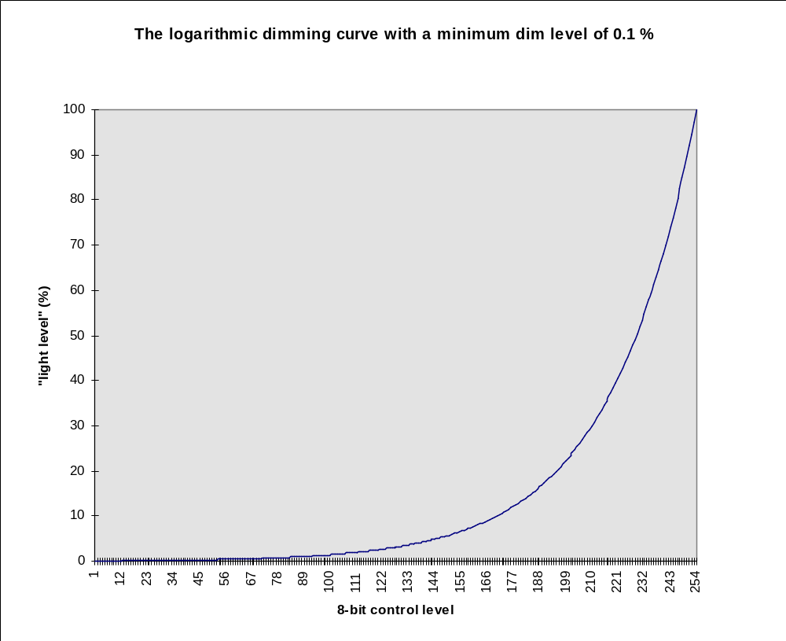

Appendix: Voltage ratings

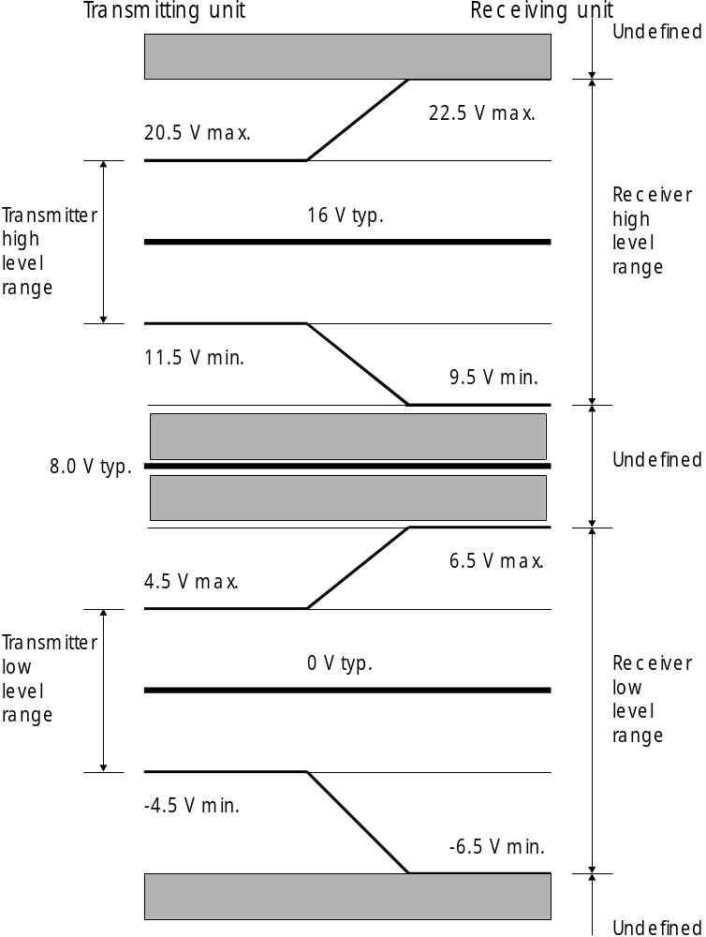

Mode of operation | Forward transmission | Backward transmission
Transmitting unit | Control Unit | Ballast
Receiving unit | Ballast | Control Unit

Appendix: Fade time and fade rate

XXXX | FADE TIME (sec) | FADE RATE  (steps/sec)
0 | <0,707 | not applicable
1 | 0.707 | 357.796
2 | 1.000 | 253.000
3 | 1.414 | 178.898
4 | 2.000 | 126.500
5 | 2.828 | 89.449
6 | 4.000 | 63.250
7 | 5.657 | 44.725
8 | 8.000 | 31.625
9 | 11.314 | 22.362
10 | 16.000 | 15.813
11 | 22.627 | 11.181
12 | 32.000 | 7.906
13 | 45.255 | 5.591
14 | 64.000 | 3.953
15 | 90.510 | 2.795

